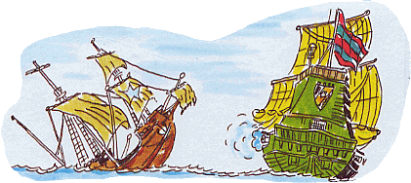**B a t t l e s h i p**

|  |  |  |  |  |  |  |  |  |  |  |
| --- | --- | --- | --- | --- | --- | --- | --- | --- | --- | --- |
|  | **A** | **B** | **C** | **D** | **E** | **F** | **G** | **H** | **I** | **J** |
| **1** |  |  |  |  |  |  |  |  |  |  |
| **2** |  |  |  |  |  |  |  |  |  |  |
| **3** |  |  |  |  |  |  |  |  |  |  |
| **4** |  |  |  |  |  |  |  |  |  |  |
| **5** |  |  |  |  |  |  |  |  |  |  |
| **6** |  |  |  |  |  |  |  |  |  |  |
| **7** |  |  |  |  |  |  |  |  |  |  |
| **8** |  |  |  |  |  |  |  |  |  |  |
| **9** |  |  |  |  |  |  |  |  |  |  |
| **10** |  |  |  |  |  |  |  |  |  |  |

|  |  |  |  |  |  |  |  |  |  |  |
| --- | --- | --- | --- | --- | --- | --- | --- | --- | --- | --- |
|  | **A** | **B** | **C** | **D** | **E** | **F** | **G** | **H** | **I** | **J** |
| **1** |  |  |  |  |  |  |  |  |  |  |
| **2** |  |  |  |  |  |  |  |  |  |  |
| **3** |  |  |  |  |  |  |  |  |  |  |
| **4** |  |  |  |  |  |  |  |  |  |  |
| **5** |  |  |  |  |  |  |  |  |  |  |
| **6** |  |  |  |  |  |  |  |  |  |  |
| **7** |  |  |  |  |  |  |  |  |  |  |
| **8** |  |  |  |  |  |  |  |  |  |  |
| **9** |  |  |  |  |  |  |  |  |  |  |
| **10** |  |  |  |  |  |  |  |  |  |  |